------we have a table mytab(color1, color2,pname)

pname color1 color2

table brown walnut

chair white brown

-------write the procedure to find colors available for given product

i/p pname display colors in which product is available

and the color that you are getting

find other product with same color as color2 option

delimiter //

create procedure findcolor(in pname varchar(20), out pcolor varchar(20))

begin

declare vc1,vc2,vname2 varchar(20);

select col1,col2 into vc1,vc2

from mytab

where name=pname;

select name into vname2

from mytab

where col2=vc1;

select vname2,vc1

select pname,vc1,vc2

end//

cursors in plsql

cursors are similar to arrays

and is used when select statement within procedure uses multiple rows then we use cursor

if we want to read rows line by line from a table and process them

steps to use cursor

1. declare cursor

declare <cursor_ name> cursor for select statement(this returns multiple rows)

declare continue handler for not found set cset=1

1. open cursor -------when you open the cursor then the query will get executed and the data will be populated within cursor

open <cursor_ name>

1. read next row from the cursor

fetch <cursor_ name> into <list of variable>

1. check whether we have reached to last row

if cset=1 then

leave lable1

end if

1. process the data
2. repeate step 3 to 5 till you reach to end of cursor
3. close cursor

close <cursor_ name>

----- write a procedure to display all employee names and hire date for all employees working department 10

select *

from emp

where deptno=10;

delimiter //

create procedure display_empdata()

begin

declare cset int default 0;

declare vname varchar(20);

declare vdt date;

declare empcur cursor for select ename,hiredate from emp where deptno=10;

declare continue handler for NOT FOUND set cset=1;

open empcur;

lable1:loop

fetch empcur into vname,vdt;

if cset=1 then

leave lable1;

end if;

select vname,vdt;

end loop;

close empcur;

end//

delimiter ;

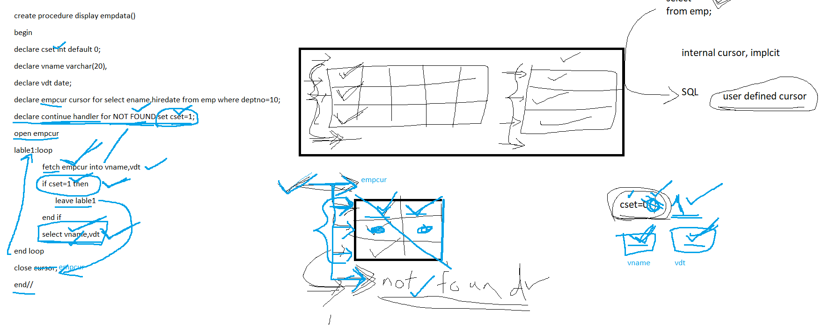

end//

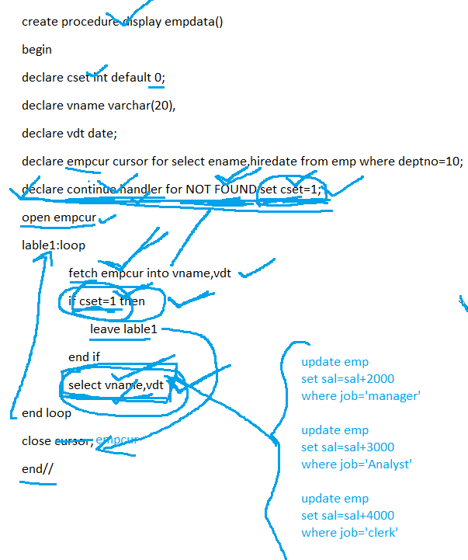

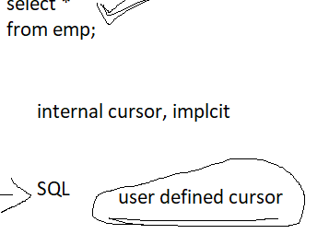

-------to delete the procedure with name myproc

drop procedure myproc

----------------

----------find discounted price for the product based on price

price=price-discount

if price< 100 discount 15%

>=100 bt < 150 10%

> = 150 8%

select *

from emp;

delimiter //

create procedure calculatediscount()

begin

declare cset int default 0;

declare vnm varchar(20);

declare vprice,vdispr decimal(9,2);

declare prcur cursor for select pname,price from product;

declare continue handler for NOT FOUND set cset=1;

open prcur;

label1: loop

fetch prcur into vnm,vprice;

if cset=1 then

leave label1;

end if;

if vprice <100 then

set vdispr=vprice-vprice*0.15;

elseif vprice < 150 then

set vdispr=vprice-vprice*0.10;

else

set vdispr=vprice-vprice*0.08;

end if;

select vnm,vprice, vdispr;

end loop;

close prcur;

end//

create procedure calculatediscount()

begin

declare cset int default 0;

declare vnm varchar(20);

declare vprice,vdispr decimal(9,2);

declare prcur cursor for select pname,price from product limit 1000;

declare continue handler for Not found set cset=1 ;

open prcur

label1:loop

fetch prcur into vnm,vprice;

if cset=1 then

leave lable1;

end if;

--------process

end loop;

end//

--------- to write a procedure to display all employeenames and job

smith----CLERK,BLAKE-----MANAGER,WARD----CLERK

delimiter //

create procedure disp_empdata(in psal int)

begin

declare cset int default 0;

declare vnm,vjob varchar(20);

declare data varchar(500) default ‘’;

declare empcur cursor for select ename,job from emp;

declare continue handler for NOT FOUND set cset=1;

open empcur;

label1: loop

fetch empcur into vnm,vjob;

if cset=1 then

leave label1

end if;

set data=concat(data,vnm,’----‘,vjob,’,’);

end loop;

select data;

close empcur;

end//

--------update salary of employees

job manager increase sal by 10%

analyst 15%

clerk 30%

otherwise 35%

delimiter//

create procedure update_sal()

begin

declare vempno,vsal int;

declare cset int default 0;

declare vjob varchar(20);

declare empcur cursor for select empno, job,sal from emp;

declare continue handler for not found set cset=1;

open empcur;

label1:loop

fetch empcur into vempno,vjob,vsal

if cset=1 then

leave label1;

end if;

#procee data

if vjob=’MANAGER’ then

update emp

set sal=vsal*1.10

where empno=vempno;

elseif vjob=’ANALYST’ then

update emp

set sal=vsal*1.15

where empno=vempno;

elseif vjob=’CLERK’ then

update emp

set sal=vsal*1.30

where empno=vempno;

else

update emp

set sal=vsal*1.35

where empno=vempno;

end if;

end loop;

close empcur;

end//

------- if you want to return a single value then you write function

concat(“hello”,”dear”)

lpad

rpad

sustr

datediff

dateformat

---------where we use these function

select

where

inside some procedure

select empno,ename,hiredate,calculateexp(curdate(),hiredate) experience

from emp

-------it allows to write functions in mysql

SET GLOBAL log_bin_trust_function_creators = 1;

delimiter //

create function calculateexp(dt1 date,dt2 date) returns int

begin

declare vexp int;

set vexp= floor(datediff(dt1,dt2)/365);

return vexp;

end//

-----------to see the code for function or procedure

show create function calculateexp;

-----write a function to calculate discount

price <100 discount 10%

>=100 and <150 15%

20

create function calculatediscount(ppr decimal(9,2)) returns int

begin

declare vdisc int default 0;

if ppr <100 then

set vdisc=ppr-ppr*0.10;

elseif ppr<150 then

set vdisc=ppr-ppr*0.15;

else

set vdisc=ppr-ppr*0.20;

end if;

return vdisc;

end//

--------to drop function

drop function calculatediscount;

-----generate email

----concat ename with 1 st 3 characters of job followed by @mycompany.com

create function generateemail(nm varchar(20), job varchar(20)) returns varchar(30)

begin

declare vemail varchar(30);

set vemail=concat(ename,’.’,substr(job,1,3),’@mycompany.com’);

return vemail;

end//